**CHAPTER FOUR**

**IMPLEMENTATION, TESTING AND RESULTS**

## 4.1 Introduction

This section deals with the various steps taken in integrating the components into a workable circuit. Developing and testing of the resulting circuit with a circuit simulator, to physical implementation and test using measuring instruments.

## 4.2 Implementation of the Security System Circuitry

The Arduino UNO board and the sensors are fixed on a breadboard first, with all components in place, to see how well they work together as a unit. This also helped with the layout because several components that were incorrectly placed were re-arranged for neatness. They were also tested with a +5V D.C power supply device connected to the PC through USB and found to work well. Certain aspects were taken into account when laying out the components. They include the kind of signal output from the sensor (analog or digital), component spacing, shape, and size, power supply source, and total components units. A registered Subscriber Identity Module (SIM) card with call credit was inserted into the SIM800 module. The servo was set to an initial position of 0 degrees with a software written in Arduino IDE of the Arduino board. The power supply circuit was constructed on a Vero-board. The modules (Arduino UNO, WI-FI and SIM800) were mounted and soldered in position. The sensors, resistors, and diodes came next. Then the servo motor and relay where also set in place. The output of the system was read through the serial monitor via COM4 when connected to the computer. Special attention was paid to serial monitor outputs, to ensure that the system behavior is as expected in relation to stimuli. Plate 4.1 shows the circuit on the breadboard with Plate 4.2 representing the circuit on a vero board.

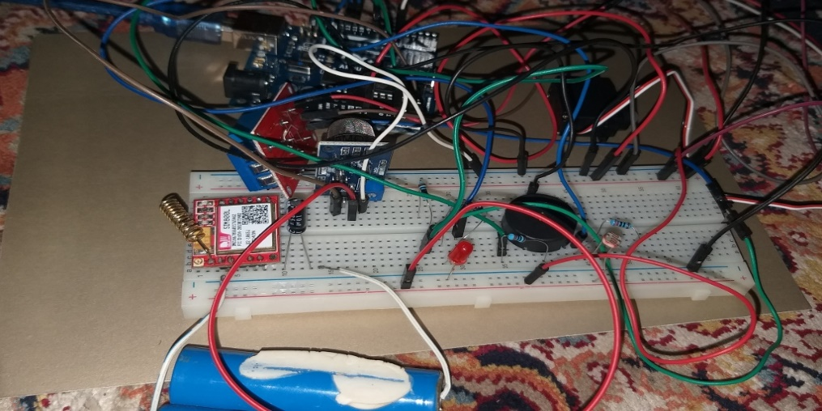

Plate 4.1: Implemented Home Security System Circuit on Breadboard

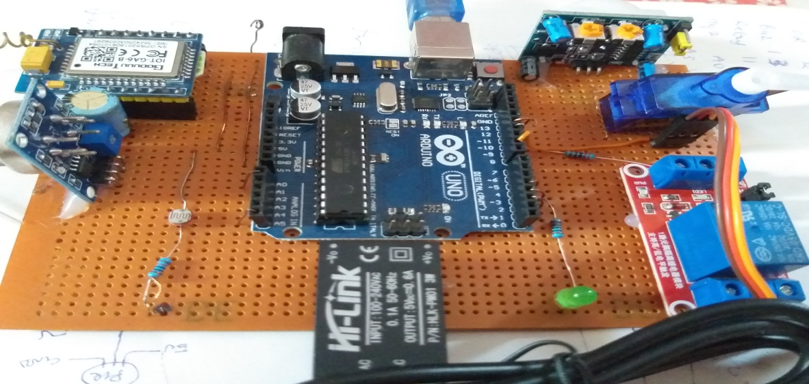

Plate 4.2: Implemented Home Security System Circuit on a Vero Board

## 4.3 Casing Design and Implementation

A choice of a suitable and attractive casing plays a great role in the final finishing of every engineering design. Therefore the following factors were considered while making a choice of the plastic casing. Plate 4.3 shows the casing used for the home security system.

1. Weight
2. Ease of installation
3. Thermal conductivity
4. Fire resistance capability
5. Mechanical support
6. Electrical conductivity
7. Waterproof

Acrylic is a tough thermoplastic that also makes for a nice enclosure, it is a good material to work with because it is so versatile and does not have shattering property. Laser engravement is very easy on it and can be treated with heat easily to create bonds and curves. General Purpose (GP), High Impact (HI) and Ultra High Impact (UHI), are the types in which they are available, their working temperature is 75 to 80, melting is 130 to 190 and they have a tensile strength of 35MPa to 65MPa (plastice.com, 2019c). GP acrylic have higher tensile strength (65MPa), hence they are commonly used compared to HI and UHI.

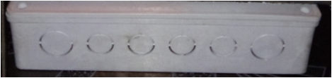

Plate 4.3: Casing of the Implemented Home Security System

**4.4** Testing of the Security System Circuit

To create signals and capture responses from the security system, which is the devices under test - DUT, electronic test instruments such as an electrical probe, digital multimeter, oscilloscope, power supply, Communication 4 (COM4) port, and test probe were utilized. This allows for the verification of the DUT's proper operation as well as the detection of any device flaws. Any system implementation in electronics systems requires the use of electronic test equipment. All the components were tested to ascertain they are working as expected. After soldering continuity test was carried out for all the components to ensure that all contacts and connections were properly made. The test employed during the project work was divided into three sections; simulation, no-load and load test which are explained in the next sub sections.

### Simulation Test

Simulation and measurement are critical components of the electrical design process; they both provide unique insights into the performance of electronic designs and complement each other in many ways. This simulation was carried out with the help of Circuit Wizard, which aided in the design of the circuit as well as testing it with the software uploaded, to ensure that it was working properly according to the design criteria. The components are then placed on a breadboard for further testing before being soldered to the vero-board. Figures 4.1shows simulation of the power supply unit with a volt meter, while Figure 4.2 shows the security system simulation with probs at interested junctions.

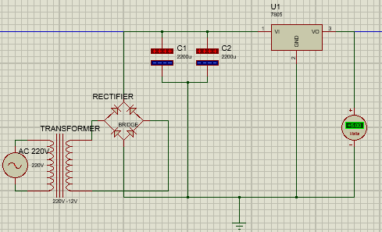

Figure 4.1: Screen Shot of the Power Supply during Simulation

### 

Figure 4.2: Screen Shot of the Security System During Simulation

### 4.4.2 No - Load Test

This test was performed on vero boards when the circuit was built. This is the verification stage, a state in which the system is powered. All components and connections have to be physically examined. This was achieved by checking for open or short circuits all closed tracks, jumper wires, etc. For one minute, power was supplied to the system. In the event of overheating, the fingertip was then utilized to feel the component temperature. The DRY (Don't Repeat Yourself) technique was also carried out to ensure the optimal utilization of memory. DRY technology is a principle adopted to eliminate software duplication in software development. Being satisfied with this test result, load test then followed.The complete system code is shown in Appendix D.

### 4.4.3 Load Test

The current circuit consumption was monitored at this step to ensure that power standards were fulfilled, the ammeter taken into consideration – if a scenario happens and when no problem exists. The response time to security situations was also tracked. The performance of the code has been examined, the program complied and executed and factors such as memory use, CPU use, reaction time and overall performance of the software have been studied. Figure 4.3 shows a screen shot of the software data being analyzed in relation to overall performance of the security system software.

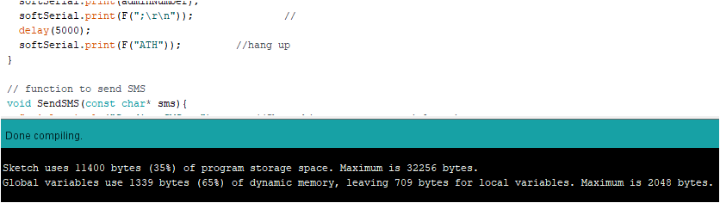

Figure 4.3: Screen Shot of the Software Parameters for the Security System

Then proceeded the voltage test. This was done using a digital multimeter. The voltage and current level were recorded and compared to the design requirements at various points on the board. Figure 4.4 illustrates the voltage and current consumption testing diagram utilized and the images taken at testing were presented in plates (4.4), (4.3) and (4.5), respectively.

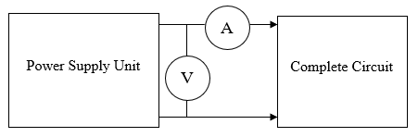

Figure 4.4: Test Diagram for Voltage and Current Consumption

The current consumption test of the system was carried out using two instances, when in sleep mode and active mode. This test was conducted, and an average value was calculated numerous times. In line with the design requirements, the voltage of the Arduino power pin was also checked. Table 4.1 presents the voltage and current analysis results coupled with the system's calculated energy consumption rate. The computation was done using Equations 4.1.

Power Consumption = (4.1)

Table 4.1: Computed Power Consumption Readings.

|  |  |  |  |  |
| --- | --- | --- | --- | --- |
| S/N | No-Load Current (A) | Load Current (A) | Full Load Voltage (V) | Power Consumption Load (kWh) |
| 1 | 0.23 | 0.42 | 5.12 | 7.91 |
| 2 | 0.24 | 0.45 | 4.97 | 8.82 |
| 3 | 0.24 | 0.46 | 4.99 | 9.25 |
| 4 | 0.20 | 0.41 | 5.09 | 7.50 |
| 5 | 0.23 | 0.43 | 5.05 | 8.18 |
| Average | 0.228 | 0.434 | 5.044 | 8.33 |

## Result

While conducting the hardware test, designed, simulated, and calculated values was taken note of for result comparison. Form Table 4.2 it can be noticed that there are marginal differences at some points in the designed values and simulated value. These differences maybe as the results of ageing of measuring equipment or even a discretization error – discernment error is the mistake coming from a computer representing a finite number of evaluations or even Iterative error in the continuous variable function.

Table 4.2: Results Comparison at Various Points in the Circuit of the Security System

|  |  |  |  |  |
| --- | --- | --- | --- | --- |
| S/N | Point | Designed value | Simulated value | Measured value |
| 1 | Rectifier output | 12.61V | 13.12V | 11.9V |
| 2 | Regulator  V1  V0 | 12.6V  5.00V | 13.12V  5.02V | 11.9V  4.89V |
| 3 | LED | 2.5V | 2.12V | 2.22V |
| 4 | LDR  1 | 5.0V | 5.04V | 4.2V |
| 5 | Relay  C1  C2  N0  NC | 12V  0V  0V  0V | 11.95V  120.5mV  49.58mV  0V | 11.84V  0V  0V  0V |
| 6 | Switch | 12V  12V  0.7V  500uA | 49.67V  49.22V  457.4mV  1.372pA | 42.46V  11.86V  0V  --- |

During the software test, the response to stimuli of the security system circuit as shown on the COM4 for the physical circuit is as programmed. The importance of this result is to know what is happening inside the main controller unit. Figure 4.5 shows the behaviour of the system when tested with security situations – as text messages are been sent. Also Plate (4.4), (4.5) and (4.6) shows the output of the multimeter during test by Figure 4.3 different intervals.

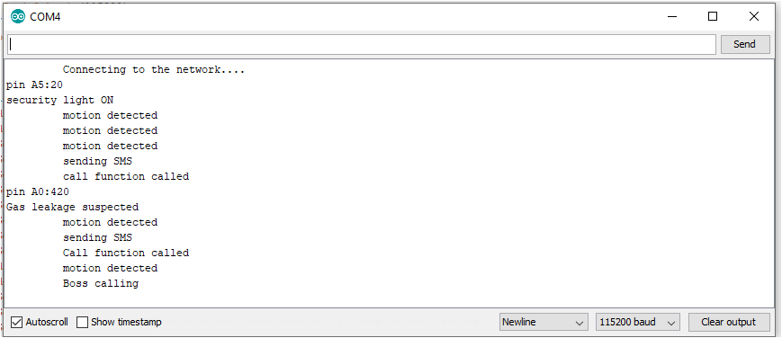

Figure 4.5: Serial Monitor Readings when Tested with Gas, Smoke, and Intrusion

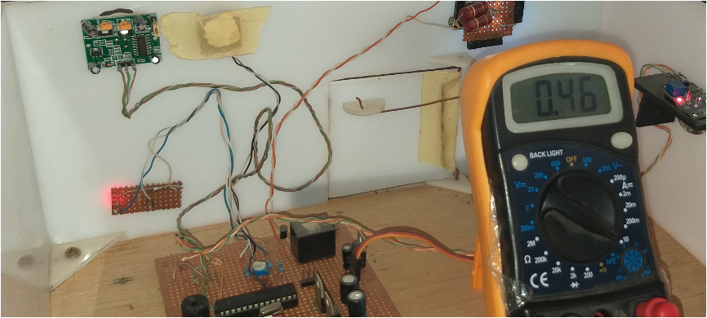

Plate 4.4: Load Current Consumption Test

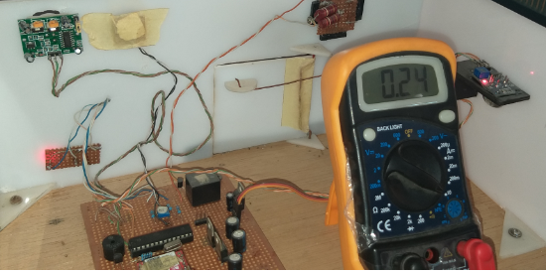

Plate 4.5: No-load Current Consumption Test

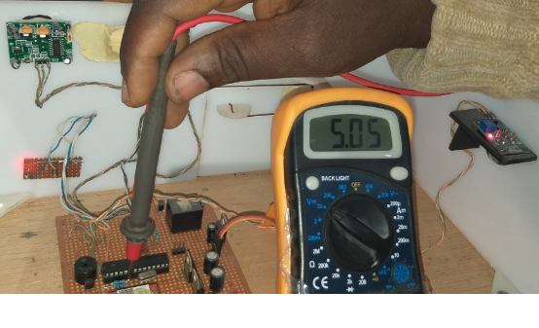

Plate 4.6: Voltage Test Reading

Also from Table 3.1 the system reliability was computed to be about 76% at 1 million hours functional time. During the computation of reliability test, ideal working environment was assumed. Using equations (3.14), a 25% improvement in system performance with respect to SMS delivery was achieved. The test was carried out by monitoring the numbers of alert messages successfully received by the homeowner during an experimental setup of intrusion in the home, with test interval of five minutes. The test was initially conducted with GSM module (A6) and then conducted again with a GSM/GPRS (SIM800) module replacing the GSM module in the security system. This process was repeated five times for each GSM module. The test set up is captured in Figure 4.6 and Table 4.3 shows the recorded values.

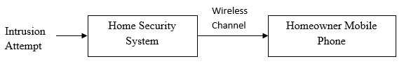

Figure 4.6: Test Diagram for SMS Count

Table 4.3: Recorded Successfully Sent Alert

|  |  |  |  |
| --- | --- | --- | --- |
| Numbers of intrusion attempt | Successfully sent alert using (A6) | | Improved successfully sent alert (SIM800) |
| 20 | | 16 | 20 |
| 20 | | 14 | 18 |
| 20 | | 16 | 19 |
| 20 | | 16 | 20 |
| 20 | | 15 | 19 |
| Average alert | | 15.4 | 19.2 |

Using equations 3.14, percentage improvement of the home security system in terms of SMS delivery was computed.

Percentage improvement =

Percentage improvement = 24.67

Percentage improvement on SMS delivery was computed to be about 25% and infinity for both email delivery and call established, the complete computation is shown in Appendix D.

Table 4.4 gives a summary of the improved features of the implemented security system compared to the work of Olarewaju *et al.,* 2017.

Table 4.4: Features of the Implemented Home Security System

|  |  |  |
| --- | --- | --- |
| **OPTIONS** | **BASE PAPER** | **IMPLEMENTED WORK** |
| **Alert Device** | Yes | Yes |
| **Surveillance System** | Yes | Yes |
| **Safety system** | No | Yes |
| **Remote Communication to Homeowner:**  **SMS**  **Phone Call**  **Email** | Yes | Yes |
| No | Yes |
| No | Yes |
| **Remote Communication from Homeowner:**  **SMS**  **Phone Call** | No | Yes |
| No | Yes |
| **Door Control** | No | Yes |

From further test conducted on the security systems, it was observed that the system response at night to intruder presence is same as at when the sky is cloudy. The system response on a night with full moon - when night is brighter is also the same as when it is evening time.

Finally, from the result obtained above, and the responses at the COM4, the security system’s accessibility and versatility has been improved, which in turn will improve the the level of security in our homes if deployed.